Polarization Maintaining Optical Circulator

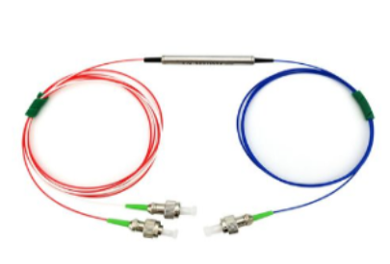

Features
- Low Insertion Loss
- High Extinction Ratio and High Isolation
- Available for Slow or Fast Axis App
- High Stability and Reliability

Applications
- EDFA
- Fiber Optical Instrument
- Fiber Laser
- Fiber Sensor

Specifications

Parameters | Unit | Type A |  | Type B
Operating wavelength | nm | 1310 or 1550 |  | 1064
Bandwidth | nm | ±30 | ±20 | ±5
Typ. Isolation | dB | 46 | 30 | 30
Isolation | dB | ≥40 | ≥20 | ≥25
Typ. Insertion Loss | dB | 0.7 | 0.6 | 1.8
Insertion Loss  @,-5 to +70（1310/1550nm），  ,-5 to +50（1064nm） | dB | ≤0.9 | ≤0.8 | ≤2.1
Extinction Ratio | dB | ≥22 | ≥20 | ≥20
Cross Talk | dB | ≥50
Return loss | dB | ≥50
Power handling | mW | ≤300 |  | ≤300
Fiber Type（panda Fiber） | / | 1310nm :PM 1310;1550nm:PM1550;  1064nm:PM980.
Ports Marking color  (only for 250um bare fiber) | / | Port1 :Black ,Other ports :Clear
Ports labeling(only for devices  with 900um loose tube ) | / | 900um Red loose tube for all port
Operating temperature | ℃ | -5 ~ +70 | -5 ~ +70 | -5 ~ +50
Storage temperature | ℃ | -40 ~ +85
Dimensions | mm | φ5.5 × L50(P1) (only for bare fiber or 900um loose  tube)
Dimensions | mm | L90*W20*H10（ABS）(P2) (only for 3mm or 2mm cable)

*Above specifications are for devices without the connectors.
*For devices with connectors, IL will be 0.3dB higher, RL will be 5dB lower, and ER will be 2dB lower.
*The PM fiber and the connector key are aligned to the slow axis, fast axis is blocked

- Package Dimension

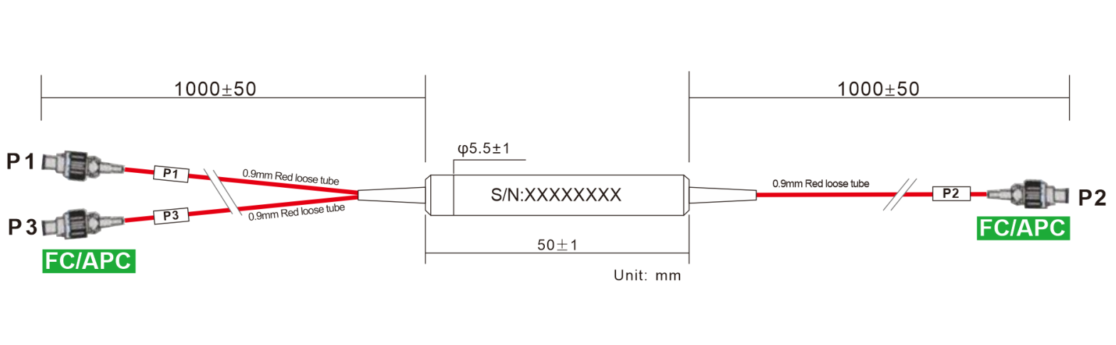

- Ordering information

PMCIR | - | XXX | XXX | XX | XX | XXX | XX | XX | - | X | X
 |  | Port NO | Wavelength | Type  Stage | Axis | Modules type | Fiber Type | Fiber Length |  | Com connector | Port Connector
PMCIR= PM  Circulator |  | 03=3 Ports | 106=1064nm | S= Single  Stage | SA=  slow axis | ST1=Ф5.5X50 | 02=250um fiber | 10=1.0m |  | 0=None | 0=None
PMCIR= PM  Circulator |  | 22=2X2 | 131=1310nm | P= Daul  Stage |  | SB=90 X20 X10 | 09=0.9mm Tube | XX=Customized |  | 1=FC/UPC | 1=FC/UPC
PMCIR= PM  Circulator |  |  | 155=1550nm |  |  | XX=Customized | 20=2.0mm Tube |  |  | 2=FC/APC | 2=FC/APC
 |  |  | 165=1650nm |  |  |  | 30=3.0mm Tube |  |  | 3=SC/UPC | 3=SC/UPC
 |  |  | 148=1480nm |  |  |  | XX=Customized |  |  | 4=SC/APC | 4=SC/APC
 |  |  |  |  |  |  |  |  |  | 5=LC/UPC | 5=LC/UPC
 |  |  |  |  |  |  |  |  |  | 6=LC/APC | 6=LC/APC
 |  |  |  |  |  |  |  |  |  | X=Customized | X=Customized

Part Number | Product Description
PMCIR-03155PSAST10910-22 | PM Circulator Steel Tube Device，dual stage, Corning PM 1550nm Panda fiber with 0.9mm red loose Tube, length fiber 1m , FC/APC connector, P grade, slow axis working only

Part Number | Product Description
PMC-2215590ST10910-22(S) | 2*2 Filter PM Fiber Coupler，Splitting Ratio 90/10, Steel Tube type, PM 1550nm Panda fiber With 0.9mm Hytrel White Tube,  fiber Length 1m (with connector)， connector FC/APC，  connector key is aligned to slow axis.

